# Section 4: The Enlightenment of Buddha Gotama (At Age 35)

Tradition holds that the Blessed One attained supreme enlightenment in the year 589 B.C., on the full moon day of Vesākha (May), at Bodh Gaya—then known as Uruvelā. [1] This momentous event marked the dawn of a new era in human history, illuminating the path to liberation for countless beings. In this section, we focus on the profound events leading up to and following this noble awakening.

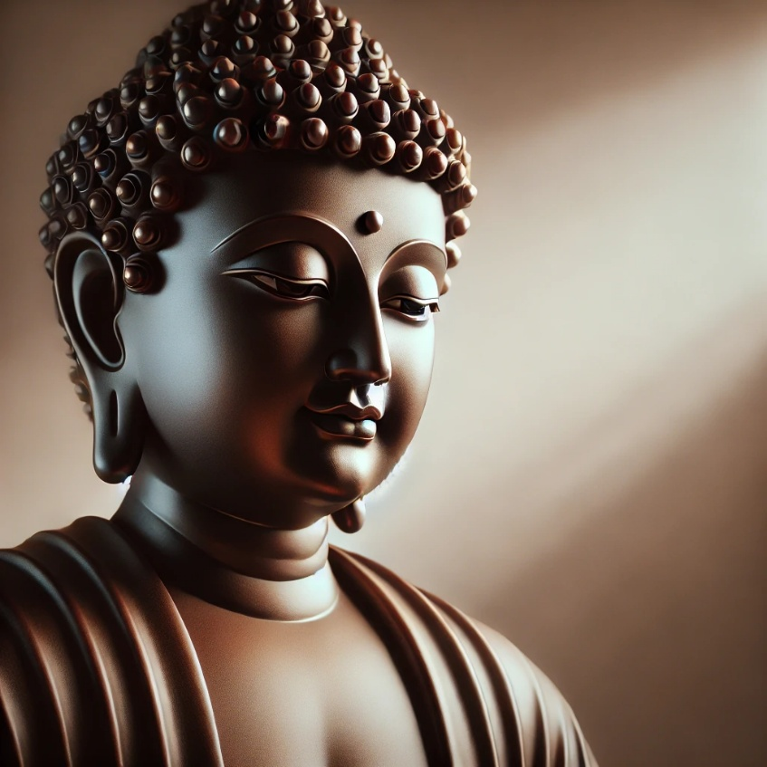

**Compassionate Buddha [2]**

## Events Leading to Enlightenment

As we have seen in the previous section (section:3), Ascetic Siddhartha abandoned extreme austerities, reflecting deeply on his childhood meditative attainments and realizing, through wisdom, the true way to liberation. Strengthening his body to endure the final striving, he prepared himself for the ultimate breakthrough. [3]

However, his new mode of practice was misunderstood by the five ascetics who had been attending to him. Disillusioned, they left him and departed for the Deer Park at Isipatana. [4] Unshaken in his resolve, the Bodhisatta remained on the banks of the Nerañjanā River, dwelling in solitude, firm in his determination to attain the ultimate truth.

In the scriptures, we find a profound account of how he overcame the forces of Māra and realized what is called the *“superhuman distinction in knowledge and vision worthy of the noble ones”* (*alam-ariya ñāṇadassana visesa*). [5]

This was the final battle before enlightenment—the triumph of wisdom over delusion, of truth over ignorance.

### The Five Great Dreams

Before his enlightenment, the Bodhisatta experienced five extraordinary dreams—visions that foreshadowed his awakening and the immense impact his teachings would have on the world. In his own words:

*“Bhikkhus, before my enlightenment, while I was still a Bodhisatta, not yet fully awakened, five great dreams appeared to me. What five?”* [6]

1. **The Earth as His Bed**   
   He dreamt that the vast earth was his bed, the mighty Himālaya his pillow, his left hand rested on the eastern ocean, his right on the western, and his feet on the southern sea. This signified his coming enlightenment—an awakening that would shake the entire world and bring boundless benefit to all beings.
2. **The Grass Touching the Sky**  
   He saw a sacred grass (*tiriyā*) growing from his navel, stretching up and touching the sky. This represented his realization of the Noble Eightfold Path and his role in proclaiming it to devas and humans alike.
3. **White Worms with Black Heads**  
   He dreamt of white worms with black heads crawling from his feet up to his knees, covering them completely. This symbolized the vast number of lay disciples who would embrace his teachings and follow his path.
4. **The Four Birds Turning White**  
   Four birds of different colours—coming from the four directions—fell at his feet and turned completely white. This signified that people from all social classes—khattiyas (nobles), brahmins (priests), vessas (merchants), and suddas (labourers)—would renounce the household life, enter the monastic path, and become his disciples.
5. **Climbing a Mountain of Dung**  
   He saw himself ascending a massive mountain of dung, yet remaining completely unsoiled. This symbolized his future life as a renunciant, where he would receive the four requisites—robes, alms food, shelter, and medicine—without attachment, free from craving and clinging. [7]

### The Significance of These Dreams

Tradition holds that these five dreams were profound premonitions (*pubbanimitta*), revealing that the Bodhisatta was on the threshold of Buddhahood. They foretold his awakening and the vast, transformative reach of his teachings, which would shine across generations, guiding countless beings to the path of liberation.

## Encounters with Māra [8]

On the occasion when the Ascetic Siddhartha was sitting in meditation under the *assattha* bodhi-tree [9], in the bank of Nerañjanā, river, Māra wanted to discourage him from attending liberation, wanted to hold him in his grip. Below we can see a passage from Suttanipata, how the Māra, was trying to persuade the Ascetic Siddhartha away from Buddhahood.

The Buddha elaborates this event thus:

“As I strove to subdue myself  
beside the broad Nerañjanā,  
absorbed unflinchingly to gain  
the surcease of bondage here,  
Namucī [10] came and spoke to me  
with words all garbed in pity thus:

**Māra**

‘…you are thin and you are pale,  
and you are in death’s presence too:

a thousand parts are pledged to death  
but life still holds one part of you.  
Live, sir! Life’s the better way;  
you may gain merit if you live,

come live the life of purity, pour  
libations on the holy fires  
and thus a world of merit gain.  
What can you do by struggling now?

The path of struggling too is rough,  
and difficult and hard to bear…’

**The Bodhisatta replied**:

O Evil One, O Cousin of the Negligent,

you have come here for your own ends.

Now, merit I need not at all.   
Let Māra talk of merit then,  
to those that stand in need of it.

For I have faith and energy,  
and I have understanding, too.  
So while I thus subdue myself,  
why do you speak to me of life?

There is this wind that blows, can dry  
even the rivers’ running streams;  
so while I thus subdue myself,  
why should it not dry up my blood?

And, as the blood dries up, then bile  
and phlegm run dry, the wasting flesh  
becalms the mind: I shall have more  
of mindfulness and wisdom too,  
I shall have greater concentration.

For living thus, I come to know  
the limits to which feeling goes.  
My mind looks not to sense-desires:  
Now see a being’s purity…” [11]

Having understood the unshakeable determination of the bodhisattva, and that he has no power to defeat him, with a heavy heart Māra went away.

# Profound Reflections on the Path of Awakening

## The Power of Right Effort

The essence of the Dhamma message presented here is the unwavering effort required to walk the spiritual path. Right Effort (*sammāvāyama*), a vital aspect of the Noble Eightfold Path, is the foundation of spiritual progress. It is the dedicated resolve to:

* Abandon unwholesome qualities that have already arisen,
* Prevent unwholesome qualities from arising,
* Cultivate wholesome qualities that have not yet arisen, and
* Strengthen and develop wholesome qualities that already exist.

Right Effort is not merely a discipline—it is a compassionate and guiding force, a helping hand that uplifts us toward the ultimate goal of liberation.

## The Offering of Sujātā—A Moment of Significance

Tradition tells us that on the morning of his enlightenment, the Bodhisatta Siddhartha received a nourishing meal of milk rice from Sujātā, the daughter of a householder in the village of Senani near Uruvelā. [12] While the scriptures do not explicitly mention this event, the *Anguttara Nikāya* (AN 1:258) offers a striking reference to her:

***“…the foremost of my female lay followers in being the first to go for refuge is Sujātā, daughter of Senānī.”***

This passage suggests that she played an unparalleled role in the Buddha’s journey, offering a gift of sustenance that would empower him to take his final steps toward enlightenment.

## The Sacred Act of Offering

The *Mahāparinibbāna Sutta* (DN:16) records the Blessed One’s words about two uniquely meritorious acts of giving:

***“…these two alms-giving’s are of very great fruit, of very great result, more fruitful and advantageous than any other. Which two? The one is the alms-giving after eating which the Tathāgata attains supreme enlightenment, the other that after which he attains the Nibbāna-element without remainder at his final passing.”***

We know that the final alms-giving before the Buddha’s passing was offered by Cunda. [13] But who, then, provided the meal before his enlightenment? Though the sutta remains silent on this, tradition leads us to consider Sujātā as the one who offered this auspicious gift.

### Sujātā—The First Lay Woman to Take Refuge?

A deeper reflection on the Buddha’s words raises an intriguing possibility: could Sujātā have been the very first laywoman to pay homage to the newly enlightened Buddha? In *Anguttara Nikāya* (AN 1: XIV), all other lay disciples described as foremost in different qualities are those who sought refuge in the Buddha after his enlightenment. Could Sujātā’s refuge have been an act of devotion preceding all others?

In contrast, the *Vinaya Piṭaka* [14] tells us that the first male lay disciples were the merchants Tapussa and Bhallika, who encountered the Buddha after his awakening. The Buddha acknowledged them as the first to take refuge, saying:

*“Bhikkhus, the foremost of my male lay followers in being the first to go for refuge are the merchants Tapussa and Bhallika.”* (AN 1:248)

Having received his alms, they bowed before the Blessed One and declared:

*“Sir, we go for refuge to the Buddha and the Teaching. Please accept us as lay followers who have gone for refuge for life.”*

They thus became the first lay followers by way of the Double Refuge (*Buddha* and *Dhamma*).

This raises a compelling question: Was Sujātā’s offering a reverence to the ascetic Siddhartha before his enlightenment? Or was it a tribute to the newly awakened Buddha, the first act of homage by a laywoman? While the answer remains uncertain, her role in the sacred unfolding of the Buddha’s enlightenment remains undeniably profound.

# Supreme Enlightenment – Sammāsambodhi

With unwavering determination and an unshakable resolve for liberation, the Bodhisatta strengthened his courage and deepened his effort. Through relentless striving and heedfulness, he overcame the formidable forces of Māra and his tenfold army, ultimately attaining the supreme enlightenment. [15]

## The Blessed One’s Words on Effort and Determination

The Buddha himself described the depth of his perseverance in these stirring words:

*“…Bhikkhus, …I strove indefatigably… ‘Willingly, let only my skin, sinews, and bones remain, and let the flesh and blood dry up in my body, but I will not relax my energy so long as I have not attained what can be attained by manly strength, energy, and exertion.’ It was by heedfulness that I achieved enlightenment, bhikkhus; it was by heedfulness that I achieved the unsurpassed security from bondage…” [16]*

His supreme awakening was not granted by chance, nor was it the result of mere aspiration—it was attained through boundless perseverance, unwavering heedfulness, and an indomitable spirit.

## The Blessed One’s Declaration of Enlightenment

Upon attaining supreme awakening, the Blessed One proclaimed:

*“…I am now the Arahant and fully enlightened Buddha, of the Gotama clan… I became fully enlightened at the foot of an assattha tree…”[17]*

Reflecting on the profound transformation he had undergone, he declared:

*“Then, bhikkhus, being myself subject to birth, aging, sickness, and death—having realized the peril in all that is subject to birth, aging, sickness, and death—I sought the unborn, unaging, unailing, deathless, supreme security from bondage. And I attained it… I attained the sorrowless, undefiled, supreme security from bondage: Nibbāna.*

*The knowledge and vision arose in me: ‘My deliverance is unshakeable; this is my last birth; now there is no renewal of being.” [18]*

## The Path to Enlightenment

After his awakening, the Buddha reflected deeply on the arduous journey that had led him to supreme realization. As he rested beneath the Goatherd’s Banyan Tree on the banks of the Nerañjarā River in Uruvelā, he contemplated:

*“I am indeed freed from that grueling asceticism! It is truly good that I am freed from that futile and tormenting path! Steady and mindful, I have attained enlightenment.”* [19]

Rejoicing in the wisdom that had shattered delusion, he proclaimed:

“Having seen the futility of austere practices  
Aimed at the deathless state,  
That all such penances are in vain,  
Like oars and rudders upon dry land,

By cultivating the true path—  
Virtue, concentration, and wisdom—  
I have attained supreme purity:  
You are defeated, O End-maker.”[20]

Māra, the End-maker (*antaka*), who binds beings to the cycle of death, had been utterly vanquished. The Buddha had triumphed, and the path to liberation was illuminated for the world.[21]

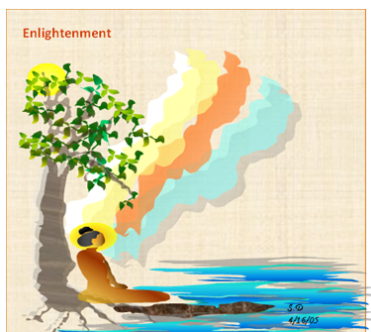

**“…being myself subject to birth… ageing… sickness … death…sorrow…and defilements…I attained the supreme security from bondage, Nibbāna. The knowledge and vision arose in me: ‘My deliverance is unshakeable This is my last birth; now there is no renewal of being” [22].**

# What is Full Enlightenment? – The Meaning of Sammāsambuddha

Sammāsambuddha—the Fully Enlightened One—is one of the nine noble qualities of the Tathāgata. These nine qualities, as proclaimed in the scriptures, are:

*“…The Blessed One is an Arahant, perfectly enlightened, accomplished in true*

*knowledge and conduct, fortunate, knower of the world, unsurpassed trainer of persons to*

*be tamed, teacher of devas and humans, the Enlightened One, the Blessed One.” [23]*

When we reflect upon these nine noble qualities, we find that they all converge into a single, supreme truth—the Buddha is **the Fully Enlightened One (Sammāsambuddha)!** This title embodies his perfect wisdom, boundless compassion, and unparalleled mastery over the path to liberation. [24]

## The Nine Noble Qualities of the Blessed One

### 1. Arahant – The Accomplished One

The Buddha is an **Arahant**, having completely eradicated all defilements, severed the cycle of saṁsāra, and put an end to rebirth. Free from all taints, he is worthy of the highest veneration by both gods and humans. [25]

### 2. Sammāsambuddha – The Fully Enlightened One

The Buddha is called Sammāsambuddha because:

* He has discovered (*buddha*) all truths rightly (*sammā*) and by himself (*sāmam*).
* He fully comprehended the Four Noble Truths.
* He awakened from the great sleep of delusion.
* He attained true omniscience, perceiving all things as they truly are.

### 3. Vijjācaraṇa Sampanno – Endowed with True Knowledge and Conduct

The Buddha possessed both supreme wisdom (*vijjā)* and the highest perfection of virtue ***(****caraṇa),* fulfilling the ideal of complete purity in knowledge and action.

**The Threefold Knowledge (*Tevijjā*)**:

1. Knowledge of past lives (*pubbenivāsānussati ñāṇa*).
2. Divine eye (*dibba-cakkhu*)—the ability to see the passing away and rebirth of beings according to their karma.
3. Knowledge of the destruction of all defilements (*āsavakkhaya ñāṇa*). [26]

**The Eightfold Knowledge** (expanding on the Threefold Knowledge):  
4. Insight knowledge (*vipassanā*).  
5. Supernormal powers (*iddhividha*).  
6. Mind-reading ability (*ceto-pariya-ñāṇa*).  
7. Divine ear (*dibba-sota*).  
8. The ability to create a mind-made body (*manomaya-kāya*). [27]

**Fifteen Virtuous Conducts (*Caraṇa*)**:

1. Perfected morality.
2. Guarding of the sense faculties.
3. Accomplishment in mindfulness and clear awareness.
4. Contentment.
5. Moderation in eating.
6. Wakefulness.
7. Faith.
8. Moral shame (*hiri*) and moral fear (*ottappa*).
9. Extensive learning.
10. Unwavering energy.
11. Profound wisdom.
12. - 15. Mastery of the Four Jhānas. [28]

The Buddha declared:

*“…Beyond this, there is no further development of knowledge and conduct that is higher or more perfect…” [29]*

### 4. Sugata – The Sublime One

The Buddha is Sugata, the Sublime One, because:

* He attained Nibbāna by the noble path.
* He had perfected the principles of the Ariya Path throughout his Bodhisatta journey.
* He possessed a resplendent form.
* He walked the most noble journey, free from faults.
* He entered the most beautiful realm—Nibbāna.
* His voice carried the clarity and resonance of Brahma. [30]

### 5. Lokavidū – Knower of the Worlds

The Buddha is Lokavidū, for he fully comprehended the three realms:

* The world of conditioned phenomena.
* The world of living beings.
* The world of formations governed by kamma.

He knew the nature, origin, cessation, and path beyond all worldly existence.

### 6. Anuttaro Purisadammasārathi – The Incomparable Leader of Beings to be Tamed

The Buddha is Anuttaro Purisadammasārathi—the unsurpassed guide for those who seek liberation. With supreme wisdom and boundless compassion, he leads beings across the ocean of suffering, training them according to their potential and inclinations. None can equal him—only another Sammāsambuddha.

### 7. Satthā Deva-Manussānaṃ – Teacher of Gods and Humans

The Buddha is Satthā Deva-Manussānaṃ, the Teacher of gods and men, who guides beings across the vast wilderness of saṁsāra, just as a skilled caravan leader safely leads travelers through dangerous terrain.

### 8. Buddha – The Awakened One

The Buddha is Buddha, for he is fully awakened:

* He has penetrated the Four Noble Truths.
* He has broken free from the delusion of the world.
* He has realized the fruit of ultimate liberation.

In the following sutta, the Blessed One explains why he is called the **Buddha**:

*“What must be known has been fully known,  
What must be developed has been fully developed,  
What must be abandoned has been completely abandoned.  
Therefore, brahmin, I am a Buddha.” [31]*

*‘‘Abhiññeyyaṃ abhiññātaṃ, - bhāvetabbañca bhāvitaṃ;*

*Pahātabbaṃ pahīnaṃ me, - tasmā buddhosmi brāhmaṇa”.*

Similarly, in another discourse, the Buddha beautifully expresses the purity and transcendence of an enlightened being:

*“As a lovely white lotus  
remains untainted by the water,  
I, too, remain unstained by the world.  
Therefore, O brahmin, I am a Buddha.”[32]*

### 9. Bhagavā – The Blessed One

The Buddha is Bhagavā, the Blessed One, a title of the highest reverence. He is endowed with unparalleled wisdom, virtue, and compassion. He is the one who has gained, mastered, and declared the Dhamma for the welfare of all beings. This term embodies:

* The **finest expression** of veneration and respect.
* One who is **fortunate**, having attained the highest bliss.
* One who is **liberated**, completely free from all defilements.
* One who is **fully developed**, having perfected wisdom, virtue, and compassion.

### Conclusion

Each of these nine noble qualities illuminates a different facet of the Buddha’s supreme enlightenment. Yet, together, they point to one extraordinary truth—the Buddha is **the Fully Enlightened One, Sammāsambuddha**—who, through his perfect wisdom and limitless compassion, has opened the path of liberation for all beings.

## The Rarity of a Fully Enlightened One

Reflecting on all these noble qualities, we can see that a Sammāsambuddha embodies them all. In the following sutta, the Blessed One reveals the profound significance of his presence in the world:

“My appearance in the world  
Is something exceedingly rare.  
I am the Fully Enlightened One,  
O brahmin, I am the supreme physician”[33]

*‘‘Yesaṃ ve dullabho loke - pātubhāvo abhiṇhaso;*

*Sohaṃ brāhmaṇa sambuddho, - sallakatto anuttaro.*

“I am the supreme King of the Dhamma;  
By means of the Dhamma, I turn the wheel—  
The wheel that none can stop.” [34]

*‘‘Rājāhamasmi selāti, - dhammarājā anuttaro;*

*Dhammena cakkaṃ vattemi, - cakkaṃ appaṭivattiyaṃ’’.*

## The Buddha—The Supreme Teacher

The Buddha is the noble one who discovered the path to enlightenment by himself. Having no teacher, he declared the path solely for the welfare and happiness of all beings. Venerable Ānanda affirmed this rare and extraordinary achievement**:**

“…The Blessed One, accomplished and fully enlightened,  
Was the arouser of the unarisen path,  
The producer of the unproduced path,  
The declarer of the undeclared path.  
He was the knower of the path,  
The finder of the path,  
The one skilled in the path…” [35]

## The Extraordinary Rarity of a Buddha’s Appearance

From all the testimony above, we can confirm that the presence of a Sammāsambuddha in the world is an event of profound significance—something truly extraordinary.

**Why is that?**

The appearance of a Buddha is an incredibly rare occurrence. According to the Mahāpadāna Sutta (DN:14), during the past ninety-one aeons, only seven Buddhas have arisen in the world. Buddhas appear at vast intervals of time, and during the long, immeasurable ages between their appearances, the world remains without a Buddha (abuddhassa).

In the absence of a Buddha, beings remain shrouded in the darkness of ignorance, unable to find the way to liberation. The world without a Buddha is a world without the light of wisdom—a place difficult and uncertain for those seeking the path.

**Thus, the arising of a Sammāsambuddha is not only rare but also the most extraordinary blessing for all beings.**

## The Supreme Teacher and Guide to Liberation

One of the most profound distinctions of a Sammāsambuddha is that only a Fully Enlightened Buddha possesses the ability to teach the Dhamma—to illuminate the path that leads both devas and humans toward liberation from the endless cycle of saṁsāricsuffering.

While the scriptures mention that from time-to-time Paccekabuddhas (Solitary Buddhas) arise—these noble ones attain enlightenment through their own wisdom—they do not teach the Dhamma, nor do they establish a dispensation (Sāsana) that flourishesbeyond their lifetime. Only a Sammāsambuddha has both the wisdom and the boundless compassion to proclaim the path to all beings, ensuring that the light of the Dhamma continues to shine, guiding generations long after his passing.

## The Supreme Healer of the World

A Sammāsambuddha is like the supreme physician, tending to the ailments of the world. Through his immeasurable compassion and unsurpassed wisdom, he diagnoses the root causes of suffering and prescribes the cure—the Noble Eightfold Path—leading beings toward true peace and liberation.

According to the Dhammacakkappavattana Sutta (the First Sermon), it is only a Sammāsambuddha who has the power to set in motion the Wheel of the Dhamma—a wheel that, once turned, cannot be stopped by any being in the universe. It continues to roll until the dispensation of the Buddha gradually fades from the earth.

## A Rare and Precious Opportunity

This truth should encourage and uplift the followers of the Blessed One. Even now, in this 21st century, we are living in an era where the Dhamma proclaimed by the Buddha is still available to us. We are incredibly fortunate to have knowledge of the Buddha, the Dhamma, and the Sangha—to have the opportunity to take refuge in the Triple Gem and walk the path he so compassionately revealed.

### This leaves us with a choice:

* We can **follow his guidance as lay followers**, cultivating wholesome deeds and practicing the Dhamma to lead lives of peace and happiness, both in this existence and in those to come.
* Or, if we possess **greater wisdom and courage**, we may choose the **monastic path**, dedicating ourselves fully to the spiritual life, and extending our support to others by spreading the **sublime Dhamma** that the Blessed One so tirelessly proclaimed.

## How Can We Repay the Blessed One?

The greatest way to honor and repay the Blessed One is not through mere words of gratitude, but by walking the path he illuminated for us. Through his own boundless wisdom and supreme effort, he broke through the darkness of ignorance and revealed the way to true liberation.

Later in this compilation, we will witness his untiring service to the world—from the moment of his enlightenment at the age of thirty-five, until his final passing at eighty. For forty-five years, he wandered ceaselessly, sharing the Dhamma with all who had the ears to hear.

A Sammāsambuddha is not just an enlightened being—he is the knower of the entire world, the supreme guide who alone can lead suffering beings safely to the other shore.

**May we cherish this rare opportunity, and may we strive to walk in his footsteps!**

# Events Following the Enlightenment

After the attainment of Nibbāna, the newly enlightened Buddha encountered various trials that revealed the nature of the world. These events not only demonstrate the unshakable wisdom and purity of the Blessed One but also serve as reminders for those aspiring to walk the spiritual path. While a **S**ammāsambuddha cannot be ensnared by worldly temptations, seekers of truth must remain ever-vigilant against the snares of Māra, which seek to pull them away from the path to liberation.

## Māra’s Challenge and Defeat

Soon after his enlightenment, as the Buddha sat immersed in the bliss of samādhi at Uruvelā, beneath the Goatherd’s Banyan Tree, Māra—the embodiment of delusion and death—once again approached him. Still uncertain about the Bodhisatta’s supreme liberation, Māra tried to challenge the Buddha’s path, saying:

“Having abandoned the austere practices  
By which men purify themselves,  
Being impure, you think you are pure;  
You have strayed from the path to purity.”

But the Blessed One, with unwavering wisdom, replied:

“Having seen that all austerities  
Aimed at the deathless state are futile,  
Like oars and rudder on dry land,  
I have walked the true path to enlightenment—  
A path of virtue, samadhi, and wisdom.  
I have attained supreme purity:  
You are defeated, End-maker!” [36]

Realizing that he had no power over the Buddha, Māra was vanquished. Defeated and dejected, he slunk away—like a crow that, mistaking a rock for food, pecks at it only to fly away in disappointment. [37]

## The Daughters of Māra and Their Failed Temptation

Humiliated by his failure, Māra sat nearby in sorrow. Seeing their father in despair, his daughters—Taṇhā (Craving), Aratī (Discontent), and Ragā (Passion)—approached him and asked what troubled him. Māra, still lamenting his loss, replied:

*“The Arahant, the Fortunate One in the world,  
Has gone beyond Māra’s realm:  
That is why I grieve so bitterly.” [38]*

Determined to succeed where their father had failed, the three daughters boasted of their charms, saying:

*“…With our beauty and allure, we shall ensnare him.  
As hunters trap a mighty elephant in the forest,  
We shall bind him and bring him back under your control.”*

With confidence in their powers of seduction, the daughters of Māra approached the Blessed One and, in sweet and enticing voices, tried to lure him:

*“We are at your service, ascetic…  
We shall bring you joy, O sage…”*

Yet the Buddha, who had completely transcended lust, hatred, and delusion, remained utterly unmoved. The three maidens—who could have captivated any other being in the world—found that their charms had no effect. Amazed and bewildered, they spoke among themselves:

*“Had we used these same tactics on any other ascetic  
Who was not free from lust,  
Either his heart would have burst,  
Or he would have vomited hot blood,  
Or he would have gone mad or lost his mind.  
Our father spoke the truth—this sage is beyond our reach.”*

Realizing their failure, Taṇhā, Aratī, and Ragā departed in defeat. The sutta concludes with a poetic reflection on the Buddha’s complete liberation from all worldly entanglements:

*“They came to him, glittering with beauty—  
Taṇhā, Aratī, and Ragā—  
But the Teacher swept them away right there,  
As the wind scatters a fallen cotton tuft.” [39]*

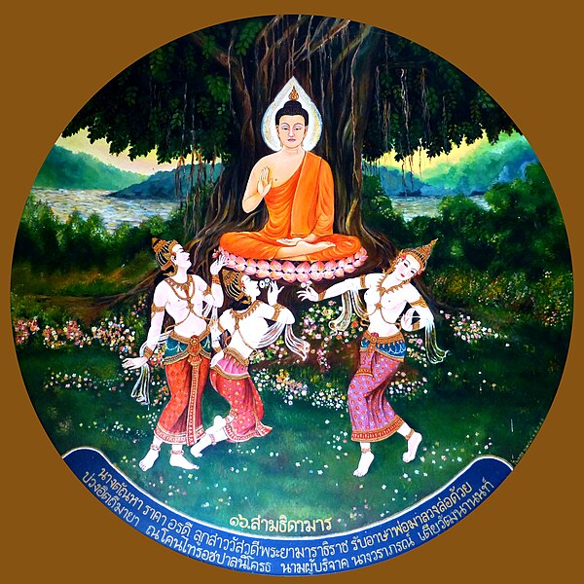

**Māra’s three daughters attempt to seduce the Buddha [40]**

## Lessons from this Event

1. **The Importance of Establishing Right View** – The foundation of the spiritual path begins with Right View. One must discern what leads to **true liberation** and what does not.
2. **Understanding the Futility of Extreme Austerities** – The future Buddha, as the ascetic Siddhartha, **realized through his own experience** that severe self-mortification was **not the path to enlightenment**. The moment he recognized its **uselessness**, he abandoned it and aligned himself with Right View. This serves as a lesson for all spiritual practitioners: if one wishes to progress, one must be willing to **let go of wrong views** and follow the **Middle Path** as revealed by the Buddha.

If one desires to nurture the Dhamma, to render Māra powerless, one must heed the words of the Buddha and practice accordingly:

*"By developing the path to enlightenment—  
Virtue, concentration, and wisdom—  
I have attained supreme purity:  
You’re defeated, End-maker!"* [41]

# The Buddha’s Peaceful Abiding’s After Enlightenment

According to the Vinaya Piṭaka, after his enlightenment, the Blessed One remained near the Nerañjanā River, dwelling in meditative bliss (*phalasamāpatti*) for seven weeks, spending seven days in one location before moving to another. The events of these weeks are summarized as follows: [42]

## According to the Vinaya Piṭaka:

🔹 **First week** – The Buddha sat under the Bodhi Tree, deeply contemplating Dependent Origination (paṭiccasamuppāda).  
🔹 **Second week** – He stayed at the Goatherd’s Banyan Tree, where he had an encounter with a brahmin from a nearby village.  
🔹 **Third week** – Under the Powderpuff Tree, he encountered the Nāga king, Mucalinda, who protected him from heavy rain.  
🔹 **Fourth week** – Under the **Ape-Flower Tree**, he received an offering of food from Tapussa and Bhallika, two merchants who became the first lay followers by taking refuge in the Buddha and the Dhamma. The devas also presented him with the first alms bowl.  
🔹 **Fifth week** – Meditating under the Goatherd’s Banyan Tree, the Buddha reflected on the profound nature of the Dhamma. Initially, he was reluctant to teach, believing that beings might not comprehend the subtle truth. At this moment, Brahma Sahampati appeared, earnestly requesting him to teach for the benefit of those with little dust in their eyes. The Buddha consented and began seeking suitable disciples.

🔸 There is no explicit mention of the seventh week in the Vinaya Piṭaka, but it states:

*"Then, after staying at Uruvelā for as long as he liked, the Blessed One set out for Benares to teach the group of five ascetics."*

The Seven Weeks of Enlightenment (According to Buddhist Tradition**)[43]**

In the popular Buddhist tradition, it is said that the Blessed One spent seven weeks near the Nerañjanā River, in the very place of his enlightenment—now known as Bodh Gaya.

These weeks are described as follows:

🔹 **First week** – The Buddha meditated under the Bodhi Tree, experiencing the bliss of liberation.

🔹 **Second week** – In gratitude to the Bodhi Tree, he gazed at it without blinking for seven days. This act of reverence is known as "Animisa Lochana Pūjā". Following this example, Buddhists pay homage to the Bodhi Tree as a symbol of enlightenment.

🔹 **Third week** – The Buddha perceived that devas in the heavens were uncertain about his enlightenment. To dispel their doubts, he performed the "Ruvan Sakkamana"—creating a golden bridge in the sky and walking up and down upon it.

🔹 **Fourth week** – The Buddha created a radiant jeweled chamber and sat inside it in deep meditation. Six-colored rays—blue, yellow, red, white, orange, and a combination of all five—shone from his body. Each color symbolized a noble quality of the Buddha:

* **Blue** – Confidence
* **Yellow** – Holiness
* **Red** – Wisdom
* **White** – Purity
* **Orange** – Desire-lessness
* **Mixed color** – The harmonious embodiment of all noble qualities



**The Buddhist flag, displayed during religious ceremonies, represents these colors. It is a universal symbol of Buddhism, features six vertical bands representing the six colours of the Buddha's aura upon enlightenment.** [44]

🔹 **Fifth week** – Under the Banyan Tree, the Buddha had his encounter with Māra’s daughters—Taṇhā (Craving), Aratī (Discontent), and Ragā (Passion)—who failed to tempt him.

🔹 **Sixth week** – The Buddha meditated under the Mucalinda Tree, where the Nāga King Mucalinda emerged and coiled around him, shielding him from a great storm.

🔹 **Seventh week** – The Buddha sat under the Rājāyatana Tree, continuing his deep meditation. After seven weeks of fasting, he received a meal from the merchant brothers, Tapussa and Bhallika. They became his first lay disciples. [45]

According to tradition, they requested a keepsake from the Buddha, and he gave them a lock of his hair (Kesa Dhātu). They took it back to Burma (Myanmar) and enshrined it in what later became the famous Shwedagon Pagoda in Rangoon.

# Profound Dhamma Revealed During This Period

## The Cycle of Dependent Origination – The Core Teaching of the Buddha

According to the *Vinaya Pitaka*, soon after his Supreme Awakening, while abiding in the bliss of liberation, the Blessed One deeply contemplated Dependent Origination (*paṭicca Samuppāda*)—both in its forward and reverse sequence: [46]

*"Ignorance conditions volitional formations; volitional formations condition consciousness; consciousness conditions name-and-form … Thus arises this entire mass of suffering. But with the cessation of ignorance, volitional formations cease … and thus, this entire mass of suffering comes to an end."*

The profound realization of Dependent Origination was a pivotal moment in the Buddha’s awakening. It revealed the interdependent nature of existence, the arising of suffering, and the path to complete cessation.

## The Buddha’s Own Reflection on Dependent Origination

In the following discourse, the Blessed One recounts his own journey of discovery before attaining Enlightenment:

*"Bhikkhus, before my awakening, while I was still a Bodhisatta, this thought arose in me: ‘Alas! This world is entangled in suffering—it is born, grows old, dies, and is reborn—yet it does not see the escape from this suffering caused by aging and death. When will an escape be known?”* [47]

### Through deep contemplation, he discerned:

*“When what exists does aging-and-death arise? By what is it conditioned?”*

Then, through his supreme wisdom, he realized:

*“Aging-and-death arises due to birth; birth is the condition for aging-and-death.”*

Following this insight, the Blessed One traced the entire cycle of existence, seeing how suffering perpetuates through ignorance, craving, and clinging. But he also saw its cessation—the path leading to ultimate liberation:

*"Thus, Bhikkhus, in regard to things unheard before, there arose in me vision, knowledge, wisdom, true knowledge, and light."* (*Cakkhu, Ñāṇa, Paññā, Vijjā, Āloka*) [48]

### Finally, with the complete cessation of ignorance, all suffering ceases:

*"With the fading away and cessation of ignorance comes the cessation of volitional formations; with the cessation of volitional formations, consciousness ceases … Thus, suffering is brought to an end."*

This sublime realization of Dependent Origination was the turning point in the history of the world—it was the direct insight that led to the Buddha’s awakening, illuminating the path for countless beings to cross beyond suffering.

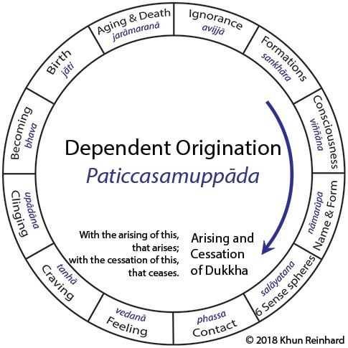

**12 Links of the Dependent Origination** -**Central Concept in Buddhism [49]**

### The Nature of Conditioned Phenomena in Dependent Origination

The principle of conditionality in *Paṭicca Samuppāda* is beautifully expressed in the following sutta:

*"When this exists, that comes to be.  
With the arising of this, that arises.  
When this does not exist, that does not come to be.  
With the cessation of this, that ceases."*

(*Imasmiṁ sati idaṁ hoti; imassuppādā idaṁ uppajjati.  
Imasmiṁ asati idaṁ na hoti; imassa nirodhā idaṁ nirujjhati.*)[50]

This profound teaching reveals the universal law of causality: all conditioned phenomena arise and cease due to specific causes. By understanding this truth, one gains insight into both the arising of suffering and the path to its cessation—the very heart of the Dhamma.

### The First Mention of Dependent Origination (Paṭicca Samuppāda)

According to the *Vinaya Piṭaka*, this is the earliest recorded instance of the Buddha reflecting on Dependent Origination (DP) after his awakening.[51]

During this profound contemplation, the Blessed One uttered his first three *Udānas* (heartfelt exclamations). A summary of these verses: [52]

*"When clarity arises in the diligent brahmin who practices deep absorption, all his doubts are dispelled. Seeing the natural order of things and their conditions, understanding the end of all conditioning—he conquers the army of Māra, like the sun shining in the sky." [53]*

## The Nature of Awakening: Dependent Origination or the Four Noble Truths?

Some who study the suttas may wonder:  
Did the Buddha’s enlightenment occur through his reflection on *Dependent Origination*, as recorded in the *Vinaya Piṭaka*? Or did the true breakthrough come with the full realization of the *Four Noble Truths*, as mentioned in his first discourse– *Setting in Motion the Wheel of the Dhamma*?[54]

What is clear, however, is that on the night of his supreme awakening, through his profound insight and deep wisdom, the Blessed One fully realized all the doctrines of the world. This is beautifully affirmed in the *Sela Sutta* where the Buddha declares to the brahmin Sela:[55]

*"What must be known is directly known,  
What must be developed has been developed,  
What must be abandoned has been abandoned.  
Therefore, brahmin, I am a Buddha."*

**The Buddha often described his enlightenment in two ways:**

1. In terms of realizing the **Four Noble Truths**
2. In terms of comprehending **Dependent Origination**

Similarly, he frequently emphasized that the path to enlightenment requires understanding **either** the Four Noble Truths or Dependent Origination, as they are two expressions of the same profound reality.

"Very frequently, we find that the Buddha expressed His experience of enlightenment in one of two ways: either in terms of having understood the Four Noble Truths or in terms of having understood the nature of Dependent Origination. Again, the Buddha has often mentioned that in order to attain enlightenment, one has to understand the Four Noble Truths; or similarly, one has to understand Dependent Origination."[56]

# Who is an Arahant?

This is the first recorded instance in the scriptures where the term **‘Arahant’** is explicitly defined.

As the newly enlightened Buddha dwelled in the bliss of liberation near Bodh Gaya, a brahmin from a nearby village approached him, inquiring about the true qualities of a brahmin. In response, the Blessed One redefined the concept, showing that a true brahmin is not simply one by birth, but rather one who has reached the highest spiritual attainment—**an Arahant**:

*"The brahmin who has abandoned all unwholesome qualities, who is humble, free from flaws, and self-controlled, who has attained final knowledge and fulfilled the spiritual life—he alone may rightfully call himself a brahmin, having no conceit about anything in the world." [57]*

## Definition of an Arahant

In the Mahā Assapura Sutta (MN:39), the Buddha further explains:

"Bhikkhus, how is one truly an Arahant?  
For him, all evil and unwholesome states—those that defile, lead to renewed existence, bring trouble, ripen in suffering, and result in future birth, aging, and death—are completely abandoned. That is how a bhikkhu is an Arahant."

*(‘Kathañca, bhikkhave, bhikkhu arahaṃ hoti? Ārakāssa honti pāpakā akusalā dhammā, saṃkilesikā, ponobbhavikā, sadarā, dukkhavipākā, āyatiṃ, jātijarāmaraṇiyā. Evaṃ kho, bhikkhave, bhikkhu arahaṃ hotī’”ti.)*

## The Importance of Practicing Harmlessness and Kindness Towards All Beings

One of the most profound messages conveyed by the Blessed One in the early weeks after his awakening was the significance of harmlessness (ahiṃsā) and loving-kindness (mettā) toward all living beings.

The scriptures recount a remarkable encounter during this time: as the Buddha sat in deep meditation, a great storm arose. Seeing this, Muchalinda, the Nāga King, emerged and wrapped his mighty coils around the Buddha’s body, shielding him with his hood to protect him from the heavy rains and winds.

When the storm passed and the Buddha emerged from meditation, realizing the Nāga King’s act of kindness, he uttered the following *Udāna* (inspired exclamation), emphasizing the joy and peace that arise from a life of non-harming:

*“Seclusion is bliss for the contented,  
Who sees the truth of the Dhamma.  
Kindness to the world is true happiness,  
For one who is harmless to all beings.*

*Dispassion from the world is happiness,  
For one who has overcome sensual craving.  
But transcending the conceit ‘I am’—  
This, indeed, is the highest bliss.”* [58]

This teaching closely aligns with the **Mettā Sutta**, where the Buddha declares that spreading boundless loving-kindness to all beings is an essential quality for those walking the Noble Path.

**Note**: Apart from being harmless, in here we can see some other essential qualities supporting the spirituality such as seclusion, loving kindness (metta) to all, dispassion towards worldly things and abandon of conceit.

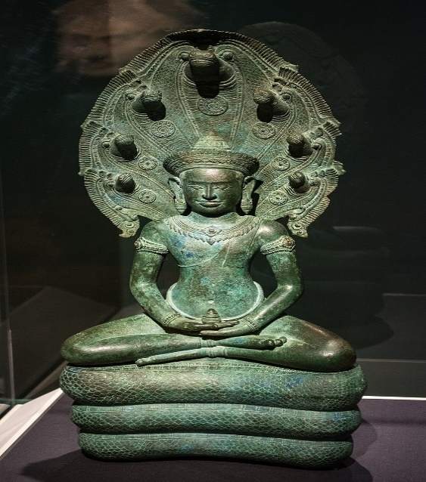

**Muchalinda Naga giving protection to the Buddha [59]**

# Honouring the Dhamma

Not long after hi*s* Supreme Awakening, while dwelling at Uruvelā, on the banks of the Nerañjarā River, beneath the Goatherd’s Banyan Tree, a profound reflection arose in the Blessed One’s mind: [60]

*“One who lacks reverence and respect dwells in suffering.  
Now, which ascetic or brahmin could I honour, respect, and depend upon?”*

As he contemplated, the Buddha realized:

*“I do not see any ascetic or brahmin more accomplished than myself  
in knowledge and vision of liberation,  
whom I could honour, respect, and rely upon…*

*Let me then honour, respect, and dwell in dependence  
on the very Dhamma to which I have fully awakened.”*

*This profound resolution of the Blessed One reminds us that the highest refuge is not in any individual but in the* ***timeless truth of the Dhamma itself****—the path of wisdom, virtue, and liberation.*

This shows the great wisdom and humility of the Buddha recognising the greatness of the Dhamma and sharing his experience with his disciples urging them to honour the Dhamma. This is a very important message to Buddhists- to understands the significant of the Dhamma—the teaching, he stressed this point on his last days of life conveying the important message – saying when **the Buddha is no more – Dhamma will guide everyone.** [61]

Hence, we Buddhist rely on Dhamma and live and practice according to Dhamma would never fall out from our spiritual path!

## Dhamma should be revere

“Therefore, one desiring his own good,

Aspiring for spiritual greatness,

Should deeply revere the true Dhamma,

Recollecting the Buddhas’ Teaching”. [62]

## Profundity of the Dhamma

Another significant Dhamma factor revealed during that time the Buddha was pondering of depth of the Dhamma he fathomed during the night of his awakening: understanding the causality (dependent origination) and giving up all attachments (abandoning greed -tanha) which led him to liberation. He reflected thus:

“*I have discovered this profound truth, so hard to see, so hard to comprehend. It’s peaceful and sublime, subtle, beyond the intellect, and knowable only to the wise…”* [63]

Following his reflection of the depth of the Dhamma, the Buddha felt that ordinary beings who are immersed in sensual pleasures would not be able to understand the realty and was hesitate to teach. This is what he thought:

‘*Enough with teaching the Dhamma*

*That even I found hard to reach;*

*For it will never be perceived*

*By those who live in lust and hate.*

*Those dyed in lust, wrapped in darkness*

*Will never discern this abstruse Dhamma*

*Which goes against the worldly stream,*

*Subtle, deep, and difficult to see”. [64]*

## Brahmā Sahampati’s Invitation

The Buddha describes the event:

“ …then, bhikkhus, the Brahmā Sahampati knew with his mind the thought in my mind and he considered: ‘The world will be lost, the world will perish, since the mind of the Tathāgata, accomplished and fully enlightened, inclines to inaction rather than to teaching the Dhamma.’

“…then, just as quickly as a strong man might extend his flexed arm or flex his extended arm, the Brahmā Sahampati vanished in the Brahma-world and appeared before me. He arranged his upper robe on one shoulder, and extending his hands in reverential salutation towards me, said:

“*Venerable sir, let the Blessed One teach the Dhamma, let the Sublime One teach the Dhamma. There are beings with little dust in their eyes who are wasting through not hearing the Dhamma. There will be those who will understand the Dhamma -arise, victorious hero, caravan leader, Debtless one, and wander in the world. Let the Blessed One teach the Dhamma, there will be those who will understand.’[65]*

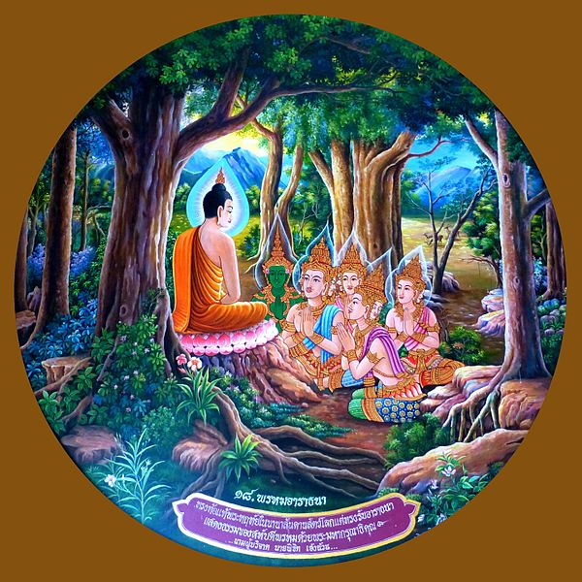

**Invitation of Brahma Shampati [66]**

## The Blessed One’s Response

*“ ‘Open for them are the doors to the Deathless, let those with ears now show their faith. Thinking it would be troublesome, O Brahma, I did not speak the Dhamma subtle and sublime’… Then Brahma Shampati thinking: ‘The Blessed One has consented to my request that he teach the Dhamma.’ and after paying homage to me, keeping me on the right, he thereupon departed at once”.[67]*

This is the first occasion Brahma Sahampati, follower of the Blessed One meeting the newly attained Buddha [68] The Blessed One with great compassion consented to his request.

This incident demonstrates the Noble Qualities of the Buddha. He had the humility -modesty to accept the request of Brahma Sahampati to proclaim the Dhamma for the people who could get immense benefits from hearing the good Dhamma. He also displayed his highest wisdom by accepting a good advice.

# Significant Events During This Time

## The First Step Toward the Establishment of the Fourfold Assembly

The Fourfold Assembly (*catuparisā* in Pali) refers to the four groups who follow the Buddha’s teaching: monks, nuns, laymen, and laywomen. In the history of the Buddha’s dispensation, we can see that the foundation of the Fourfold Sangha was laid during this period.

At that time, two brothers, Tapussa and Bhallika, were traveling from Ukkalā to Uruvelā, near the place of the Buddha’s enlightenment. Following the advice of a deva, they offered food to the Buddha. After making the offering, they paid homage to him and requested to be accepted as his lay followers. [69]

In establishing the dispensation, the Blessed One, recognizing the importance of monastic disciples (both monks and nuns), also encouraged lay followers to become his disciples. This was not only for their own spiritual development but also to ensure the monastic community received the necessary support in the form of the four requisites essential for their survival.

From the time of the Blessed One until the present day, the unwavering support of lay devotees has enabled the Buddha’s dispensation to continue flourishing and illuminating the world. A detailed account of this event is provided in Section 4.1.

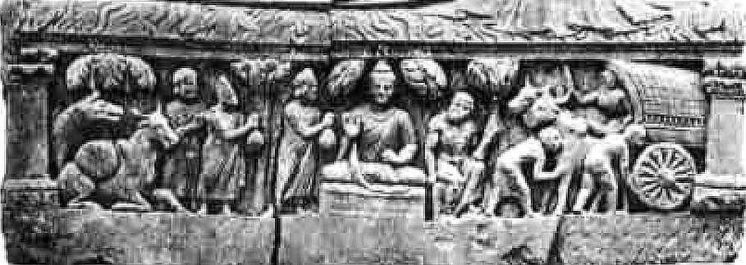

**Tapussa and Bhallika**, **offering food to the Blessed One** [70]

## First Instance of Devas and Non-Humans Paying Homage

Both scriptures and legends recount numerous instances of devas and non-humans, such as Nāga kings, paying homage to the Blessed One. They often approached him to ask questions about the Dhamma or to listen to his discourses. Earlier, we saw how the Nāga King Muchalinda paid homage to the Buddha.[71]

On the occasion when the two brothers, Tapussa and Bhallika, wished to offer food to the Buddha, the Four Great Kings presented four alms bowls so that the Blessed One could take his meal. We also witnessed how Brahma Sahampati honored the Buddha and earnestly requested him to teach the Dhamma. This event further illustrates one of the noble qualities of the Buddha: **"Teacher of humans and devas."**

* It is mentioned that Buddhas do not receive food with their hands. When the Blessed One was contemplating how to accept the meal offered by Tapussa and Bhallika, the Four Great Kings presented him with four crystal bowls. According to tradition, through the Buddha’s psychic potency, the four bowls merged into one. This became the first alms bowl that the Buddha carried after his awakening.
* It is also significant to note that devas recognized the **Sammāsambuddha** as the supreme being of the world and played a role in supporting the growth of the dispensation.

### Summary

* In this section, we saw how Ascetic Siddhartha, with his unwavering determination and wisdom, defeated Māra and his army, attaining supreme Buddhahood.
* We highlighted the noble qualities of a Fully Enlightened Buddha, emphasizing the importance of the appearance of an Awakened Being among those who lack knowledge of the true Dhamma.
* We briefly touched upon the period immediately following the Buddha’s awakening and the profound Dhamma teachings he revealed to the world.

In the next section (4.1), we will explore how the Buddha established his Fourfold Assembly.

### Endnotes: Section 4

1. The exact date of Buddha's enlightenment is not precisely known, as it predates written records.  It is believed to have occurred in the 6th century BCE. The most widely accepted date is around 563 BCE to 483 BCE, although different Buddhist traditions may have slightly different calculations: <https://www.quora.com/>
2. AI generated image.
3. In this sutta the Buddha said: “I considered: ‘It is not easy to attain that pleasure with a body so excessively emaciated. Suppose I ate some solid food—some boiled rice and porridge.’ And I ate some solid food—some boiled rice and porridge. Now at that time five bhikkhus were waiting upon me, thinking: ‘If our recluse Gotama achieves some higher state, he will inform us.’ But when I ate the boiled rice and porridge, the five bhikkhus were disgusted and left me, thinking: ‘The recluse Gotama now lives luxuriously; he has given up his striving and reverted to luxury. See: MN: 36 ( Mahāsaccaka Sutta)
4. The Group of five left the bodhisatta about the new moon day of Cita (April) and moved to Migadaya, the Deer Park. See: The Group of Five: The Great Chronicles of Buddhas by Venerable Mingun Sayadaw.
5. This refers to the noble state of an arahant: see: AN1:41-50 & AN:6: 77.
6. AN5:196 (Dream sutta**): see** also notes regarding this: AN: Notes: 1200 & 1201.
7. AN5:196 (Dream sutta**): see** also notes regarding this: AN: Notes: 1200 & 1201.
8. Māra is the Evil One of Buddhism, the Tempter and Lord of Sensuality bent on distracting aspirants from the path to liberation and keeping them trapped in the cycle of repeated birth and death. Sometimes the texts use the word “Māra” in a metaphorical sense, as representing the inward psychological causes of bondage such as craving and lust and the external things to which we become bound, particularly the five aggregates themselves. But it is evident that the thought world of the suttas does not conceive Māra only as a personification of humankind’s moral frailty, but sees him as a real evil deity out to frustrate the efforts of those intent on winning the ultimate goal. The proof of this lies in his pursuit of the Buddha and the arahants after their enlightenment, which would not be credible if he were conceived of merely as a psychological projection. **See**: SN: Introduction to Sgathavagga, 4. Māra samyutta p.49.
9. Bodhi tree Ficus Religiosa (Pipal tree), The Blessed One sat under this tree and attained Enlightenment, hence it is called ‘Bodhi Tree’, meaning ‘the Tree of Enlightenment’.
10. Māra is also called by this name.
11. Snp:3.2 (Padhāna sutta Translated from Pali by Bhikkhu Ñāṇamoli).
12. See Chapter 7: The Great Chronicles of the Buddhas by Venerable Mingun Sayadaw.
13. See: DN:16.
14. VP:Mahākhandaka: 4: A translation of the Pali Vinaya Piṭaka into English by Bhikkhu Brahmali.
15. Māra’s army is described as 10-fold: 1 sense-desire 2 discontent (of practice) 3 hunger & thirst 4 craving 5 dullness and drowsiness 6 cowardice 7 doubt 8 contempt & obstinacy 9 profit praise honour & fame 10 extolling of one self and scoring others. see: Snp: 3.2 (Padhana sutta, Translated by Bhikkhu Sujatho: Sutacentral Website) * In SN:4: Mārasamyutta also give detail account of Māra’s ways of obstructing the Buddha.
16. See: AN2:5 * **Note:** And being dissatisfied in striving, I strove on, standing firm without retreating-Indefatigability (*appaṭivānitā*) means not turning back, not retreating. By *I strove indefatigably*, what is meant is this: When I was a bodhisatta, I strove on, not retreating, aspiring for omniscience **“see** AN:Note:221 * This determination is found elsewhere in the Nikāyas: in AN at **8:13 §8**, IV 190,8–12; MN 70.27, I 481,1–5; and SN12:22, II 28,24–28, **see** AN:Note:222.
17. See: DN: 14 ( Mahâpadāna Sutta).
18. MN:26.
19. See: SN:4:1. **Note:** Commentary (Spk) says that this sutta mentioned the first week after the Buddha’s enlightenment. **See:** SN: Notes: 260, Buddha refers to the rigorous austerities he practiced for six years before he discovered the “middle way” to enlightenment: SN: Notes, 261,
20. SN 4:1 (The Austere Practice Sutta)
21. See: SN: Note: 265)
22. MN: 26: (The Noble Search)
23. See: AN11:11 (Mahanama sutta) & DN:3 (Ambatta sutta)
24. For detailed description of 9 noble qualities of the Buddha see:* Chapter VII Six Recollections of Visuddimagga- Path of Purification, * Suvusi Maha Gunaya (describing qualities of the Buddha, Dhamma, Sangha in Sinhala) by Venerable Rerukane Chandawimala Mahanahimi * section 5 & Buddhist Dictionary by Nyanatiloka Maha Thera.
25. This is the fourth stage of the noble path—realising the Nibbāna—arahatt-phala.
26. These three knowledges appeared at the state of enlightenment, see: MN:4 (Bhayabherava Sutta)* for more details see: DN:13 & Iti:3.5.
27. For details see: MN:4, MN:53, MN :77, DN:2, DN:3, MN:53,
28. For details see: MN:4, MN:53,AN:8:11.
29. DN:4.
30. Source:Ariyawaṁsa Dharma Pusthaka Mālava: 1-4, No1: Saptabojjangha, compiled by Venerable Moratuve Siri Sasanavansa Thera (1948) * In this sutta describes Sugatha thus: “Those for whom lust, hatred, and delusion have been abandoned, cut off at the root, made like palm stumps, obliterated so that they are no more subject to future arising: they are the fortunate ones in the world” See: SN:38:3.
31. MN:92.
32. AN 4:36 (Doṇa Sutta)
33. MN:92
34. Ibid.
35. MN:108
36. SN: 4:1. Most of the suttas in SN4: Mārasmyutta described various attempts of Māra trying to defeat the Blessed One after his enlightenment, finally, Māra the Evil One, realizing, “The Blessed One knows me, the Fortunate One knows me,” sad and disappointed, disappeared right there.
37. SN: 4:24 .
38. SN:4:25.
39. Ibid.
40. Mara's Three Daughters try to Seduce the Buddha, Chedi Traiphop Traimongkhon Temple, Hatyai, Thailand: Source: <https://commons.wikimedia.org/wiki/File:040_Mara%27s_Three_Daughters_try_to_Seduce_the_Buddha_%289270770845%29.jpg>
41. SN:4:1 **Note:** Virtue, concentration, and wisdom are the three divisions of the Noble Eightfold Path: virtue (*sīla*) includes right speech, action, and livelihood; concentration (*samādhi*), right effort, mindfulness, and concentration; and wisdom (*paññā*), right view and right intention. Māra is called the End-maker (*antaka*) because he binds beings to death, see: SN:Note:265.
42. See: VP: Mahakandhaka:1: A translation of the Pali Vinaya Piṭaka into English by Bhikkhu Brahmali.
43. See Chapter 7: The Great Chronicles of the Buddhas by Venerable Mingun Sayadaw.
44. Designed in 1884 by Henry Steele Olcott in Sri Lanka, Source: Wikipedia
45. The 7 weeks are described in: Chapter: 8: The Great Chronicles of Buddhas by Venerable Mingun Sayadaw, see also: <https://www.buddhanet.net/> * The popular cahnting of the “seven Weeks” : paṭhamaṁ—bōdhi pallaṁkaṁ, dutayaṁca—animmitaṁ tatiyaṁ—saṁkamaṇaṁ seṭṭhaṁ, catuttaṁ —ratanāgaraṁ paṁcamaṁ—ajapālaṁca, mucaliṁdēna—saṭṭhamaṁ sattamaṁ —rājayatanaṁ, vandētaṁ muṇi sēvitaṁ: Source: <https://dharmanidhaana.wordpress.com>
46. VP:Mahakhandaka: 1 The account with the Bodhi tree: Theravāda Collection on Monastic Law’: A translation by Bhikkhu Brahmali.
47. SN22:10 (Gotama the Great Sakyan Sage sutta)
48. In Dhammachakkapavthtana sutta (SN) we can see similar expression regarding awakening.
49. Source: <https://www.reddit.com/r/BuddhistMonastics/comments>
50. SN12:49
51. See: VP:Mahakhandaka: 1 & Ud: 1.3
52. Ibid.
53. Ibid.
54. SN56:11
55. MN:92
56. Source: BuddhaNet *-* [*http://www.buddhanet.net/funbud12.htm*](http://www.buddhanet.net/funbud12.htm)
57. See: VP:Mahakhandaka: 2.
58. See: VP:Mahakhandaka: 3. This event also mentioned in Ud: 1.4 (Translated by Bhikkhu Sujato <https://suttacentral.net/ud1.4/en/sujato?lang=en>)
59. 12th century Naga-enthroned Buddha Cambodia: [Cleveland Museum of Art](https://en.wikipedia.org/wiki/Cleveland_Museum_of_Art): OH, USA.Source: <https://en.wikipedia.org/wiki/Mucilinda>
60. See: SN6:2 (Reverence sutta). * The commentary (Spk ) assigns this sutta to the fifth week after the enlightenment. The sutta is also at AN II 20-21 with an additional paragraph, see: SN: Notes: 373.
61. See: DN:16
62. SN6:2.
63. See: VP: Mahākandaka :5 The account of the supreme being’s request: Translated by Bhikkhu Brahmali. This event is also mentioned in MN: 26 (Ariyapariyesena sutta)
64. MN: 26.
65. Ibid.
66. Brahma Sahampati requests the Buddha to teach despite his Reluctance, Chedi Traiphop Traimongkhon Temple, Hatyai, Source: <https://en.wikipedia.org/wiki/Creator_in_Buddhism>
67. See:MN:26. This event is also mentioned in SN 6:1 .
68. See: VP: Mahākandaka :5 The account of the supreme being’s request: Translated by Bhikkhu Brahmali
69. These 2 brothers took the refuge of the Buddha and the Dhamma as that time there was no established sangha. See: VP: Mahākandaka :4 The account with the ape-flower tree: Translated by Bhikkhu Brahmali. In AN1:248 the Buddha declared them as the first lay people to take refuge of Buddha and Dhamma.
70. Peshawar Museum: Source: <https://en.wikipedia.org/wiki/Trapusa_and_Bahalika>
71. See: Smautta Nikaya: Devastāamutta, Devaputtasamyutta, Brahmasamytta, Yakkasamyutta and Sakkasamyutata.